CNMAP API

目录

Rest services 4

Photo 4

Upload photo image 4

Get photo upload info 4

Get photo’s gps info 4

Load photo image file 5

mark best 5

remove best 5

add tags 5

Get photo info 5

update photo properties 6

delete photo 7

get photo’s camera info 7

Get photo’s near photo by location 8

Get comments 9

User 9

Get user login info 9

Get user’s tags 10

Create tag 10

Delete tag 10

Get user’s travels 10

get user’s photos 11

get user’s open info 11

get user’s own info 12

Get user’s photo’s near photo by take date 12

Get user’s photo in photos num 12

Get user’s recycle bin data 12

Empty user’s Recycle bin-清空回收站 12

Remove recycle-永久删除 13

Cancel recycle-撤销删除 13

//Get recent photos – 用户最近添加的照片 13

Comment 14

Add comment 14

Delete comment 14

Index 14

Set index page’s photo 14

Get index page’s photos 14

Panoramio 15

Get panoramio photo 15

Update photo panoramio index 16

Travel 16

Create travel 16

Edit travel attributes 16

Get travel spot 16

Edit travel spot 16

Add photos to travel 17

Get travel 17

Create travel’s spot 18

Add photos to spot 19

Rest service error_message results 19

jsp url path 20

map photo 20

User page 20

Map 20

查看全部图片 20

查看user自己的图片 20

查看user收藏的图片 20

Offensive photo 20

Photo explorer 20

Tags 20

Sql procedure 21

Update photo index 21

Get photo by map bound and zoom[ by user] 22

Get user’s photo by date or location 22

Get user’s photo panormaio 22

Get photo’s near photos by location 23

Login 23

Framework 24

growl-like notifications for angularJS projects 24

Zero watches binding for AngularJs 24

i18n in your Angular apps, made easy. 24

Highcharts JS, the JavaScript charting framework 24

The ZeroClipboard library provides an easy way to copy text to the clipboard using an invisible Adobe Flash movie and a JavaScript interface. 24

angularjs validate 24

Copy to clipboard using AngularJS 24

A spinning activity indicator 24

JavaScript source code visualization, static analysis, and complexity tool 24

|  |  |  |  |
| --- | --- | --- | --- |
| **版本** | **日期** | **功能** | **备注** |
| **3.0** | 2014年3月14日星期五 | 增加接口返回结果错误信息机制 |  |
|  |  |  |  |
|  |  |  |  |

# Rest services

## Photo

### Upload photo image

**POST** /api/rest/photo/upload

|  |
| --- |
| {  “name”: ”photo.jpg”,  “title”: ”this is photo’s title”,  “lat”: 23,  “lng”: 126,  “address”: “address in map vendor”,  “vendor”: “gaode”  } |

### Get photo upload info

**GET** /api/rest/photo/upload

### Get photo’s gps info

**GET** /api/rest/photo/{photoId}/gps[?vendor={vendor}]

* vendor参数不填或为空，则返回此图片所有gps信息；
* vendor填写供应商代码，则返回相应供应商的gps信息

|  |
| --- |
| {  "status": "OK",  "gps": [  {  "pk": {  "photo_id": 13,  "vendor": "gaode"  },  "gps": {  "lat": 31.238540880694917,  "lng": 121.4157885263236,  "alt": 0,  "address": "这是解析后的地址"  }  },  {  "pk": {  "photo_id": 13,  "vendor": "gps"  },  "gps": {  "lat": 31.240366666666667,  "lng": 121.41113333333334,  "address": "这是解析后的地址"  }  }  ]  } |

### Load photo image file

**GET** /api/rest/photo/{photoId}/{thumbLevel}

### mark best

**PUT** /api/rest/photo/{photoId}/best

### remove best

**DELETE** /api/rest/photo/{photoId}/best

### add tags

**POST** /api/rest/photo/{photoId}/tag

[{“tag”: “this is a tag”}, {“tag”: “a tag”}]

### Get photo info

**GET** /api/rest/photo/{photoId}

返回数据样例：

|  |
| --- |
| {  "status": "OK",  "prop": {  "id": 13,  "file_name": "name.jpg",  "file_size": 123132423,  "point": {  "lat": 30.257677,  "lng": 120.148931,  "address": "浙江省杭州市西湖区北山街道杭州西湖风景名胜区"  },  "vendor": "gaode",  "title": "This is title",  "description": "This is description",  "tags": [  "This a tag",  "tag",  "a tag"  ],  "create_time": 1395150024000,  "user_id": 1,  "travel_id": 11,  "travel_name": "我去了杭州",  "views": 2,  "color": "#292C40",  "comment_count": 1,  "favorite": true,  "width": 800,  "height": 500,  //"main_color": "red"  "like_count": 0,  "fav_count": 0,  "comment_count": 0,  "oss_key": "6.jpg"  }  } |

字段说明：

|  |  |  |
| --- | --- | --- |
| 字段 |  |  |
| status | OK |  |
| prop | id |  |
| user_id | 用户id |
| title |  |
| description |  |
| create_time | 创建时间 |
| views | 总访问量 |
| tags | []标签 |
| favorite | 是否收藏 |
| comment_count | 评论总数 |

### update photo properties

**POST** /api/rest/photo/{photoId}/properties

|  |
| --- |
| {  "title": "title",  "description": "description",  "point": {  "lat": 13,  "lng": 456,  "address": "dizhi"  },  "vendor": "gaode"  } |

### delete photo

**DELETE** /api/rest/photo/{photoId}

Return:

|  |
| --- |
| {  "status": "OK",  "prop": {  "id": 9,  "point": {  "lat": 31.26585422657911,  "lng": 121.44431012721591,  "address": "上海市闸北区共和新路街道沪太路775号"  },  "vendor": "gaode",  "width": 4096,  "height": 2048,  "is360": true,  "tags": [],  "favorite": false,  "create_time": "2014-05-30 01.46.49",  "user_id": 1,  "fav_count": 0  }  } |

### get photo’s camera info

**GET** /api/rest/photo/{photoId}/camerainfo

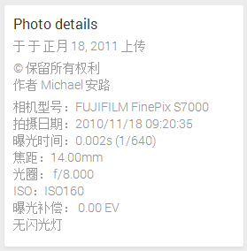

|  |
| --- |
| {  "status": "OK",  "camera_info": {  "id": 13,  "lat": 31.238540880694917,  "lng": 121.4157885263236,  "alt": 0,  "model": "iPhone 4",  "fnumber": "f/2.8",  "flash": 16,  "iso": "ISO-80",  "create_date": 1395150024000,  "username": "user",  "date_time_original": 1395150024021,  "exposure_time": "416.66666666666663/10000 s",  "focal_length": "3.85 mm",  "exposure_bias": "0 step"  }  } |

### Get photo’s near photo by location

Get /api/rest/photo/{photoId}/near[?by=loc]

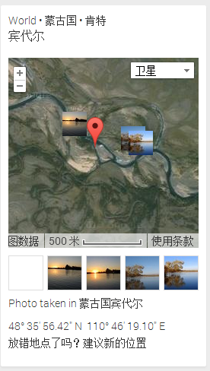

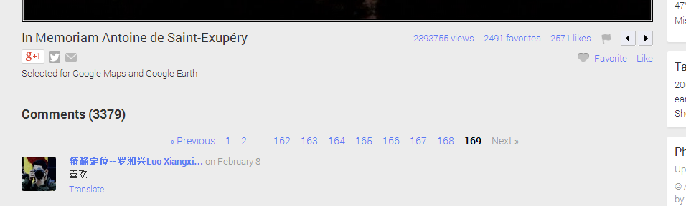

### Comment Get photo’s all comments

**GET** /api/rest/photo/{photoId}/comment

ANONYMOUS

### Comment Get photo’s comments by page

**GET** /api/rest/photo/{photoId}/comment/{pageSize}/{pageNo}

ANONYMOUS

Return:

|  |
| --- |
| {  "status": "OK",  "comments": [  {  "id": 6,  "userId": 1,  "username": "暗梅幽闻花",  "content": "阿斯顿发送到",  "createTime": 1395150024000  },  {  "id": 8,  "userId": 1,  "username": "暗梅幽闻花",  "content": "很好很强大",  "createTime": 1395150024000  }  ]  } |

## User

### Get user login info

**GET** /api/rest/user

|  |
| --- |
| {  "id": 13,  "name": "anypossiblew",  "loggedIn": true,  "roles": {  "ROLE_USER": true  }  } |
|  |

### Get user’s tags

**GET** /api/rest/user/{userId}/tag

|  |
| --- |
| {  "status": "OK",  "open_info": {  "id": 1,  "tags": [  "汉字",  "aa",  "ss"  ],  "photo_count": 0,  "photo_views": 0,  "photo_favorites": 0  }  } |
|  |

### Create tag

**GET** /api/rest/user/{userId}/tag/{tag}

### Delete tag

**DELETE** /api/rest/user/{userId}/tag/{tag}

### Get user’s travels

**GET** /api/rest/user/{userId}/travel

|  |
| --- |
| {  "status": "OK",  "open_info": {  "id": 1,  "travels": [  {  "id": 1,  "spots": [],  "createTime": 1398395453000,  "title": "无锡执行"  },  {  "id": 2,  "spots": [],  "createTime": 1398395784000,  "title": "无锡执行"  }  ]  }  } |
|  |

### get user’s photos

**GET** /api/rest/user/{userId}/photos/{ pageSize}/{pageNo}

|  |
| --- |
| {  "status": "OK",  "photos": [  {  "id": 26,  "tags": [  "798艺术区",  "北京798"  ],  "views": 0,  "favorite": false,  "create_time": "2014-03-26 04.15.53",  "user_id": 3,  "fav_count": 0  },  {  "id": 27,  "tags": [  "798艺术区",  "北京798"  ],  "views": 0,  "favorite": false,  "create_time": "2014-03-26 04.15.53",  "user_id": 3,  "fav_count": 0  }  ]  } |
|  |

### get user’s open info

**GET** /api/rest/user/{userId}/openinfo

|  |
| --- |
| {  "status": "OK",  "open_info": {  "id": 2,  "name": "admin",  "avatar": 2,  "tags": [  "上海",  "无锡之旅"  ], // 用户图片用到的所有tag  "photo_count": 119,  "photo_views": 80,  "photo_favorites": 1,  "follow": true  }  } |
|  |

### get user’s own info

Get /api/rest/user/{userId}/owninfo

### Get user’s photo’s near photo by take date

Get /api/rest/user/{userId}/photo/{photoId}/near[?by={date|loc}]

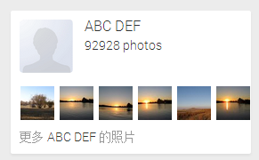

### Get user’s photo in photos num

**GET** /api/rest/user/{userId}/photos/{photoId}

|  |
| --- |
| {  "status": "OK",  "photo_info": {  "photo_count": 119,  "photo_num": 15  }  } |

### //Get recent photos – 用户最近添加的照片

### Following someone 关注用户

**POST** /api/rest/user/{userId}/following/{userId}

### Delete following someone 取消关注

**DELETE** /api/rest/user/{userId}/following/{userId}

### Get user following user

**GET** /api/rest/user/{userId}/circle

**GET** /api/rest/user/{userId}/circle/{circleId}

### 推荐关注

**GET** /api/rest/user/{userId}/follow/suggested

### 可能感兴趣的人

**GET** /api/rest/user/{userId}/follow/interested

### Get user’s follower

**GET** /api/rest/user/{userId}/follower

### Delete user’s follower 拉黑

**DELETE** /api/rest/user/{userId}/follower/{userId}

### Get message list

**GET** /api/rest/user/{userId}/messages

### Get my message list

**GET** /api/rest/user/{userId}/mymessages

## Message

### Publish a message

**POST** /api/rest/message

**Return** a message

### Get message

**GET** /api/rest/message/{id}

### Read a message

**POST** /api/rest/message/{id}/read

### remove a message from queue 删除阅读队列中的消息

**DELETE** /api/rest/message/{id}/user/{userId}

### delete owner’s message 删除自己发表的消息

**DELETE** /api/rest/message/{id}

### Share message 分享

**POST** /api/rest/message/{id}/share

## Comment

### Add comment

**POST** /api/rest/comment

ROLE_USER

Request Body:

|  |
| --- |
| {  "content": "很好很强大",  "photoId": 6  } |

Return:

|  |
| --- |
| {  "status": "OK",  "comment": {  "id": 9,  "userId": 1,  "username": "暗梅幽闻花",  "content": "很好很强大",  "createTime": 1395150024000,  "photoId": 6  }  } |

### Delete comment

**DELETE** /api/rest/comment/{commentId}

ROLE_USER

|  |
| --- |
| {  "status": "OK"  } |

Return:

## Index

### Set index page’s photo

**PUT** /api/rest/index/{photoIds}

### Get index page’s photos

**GET** /api/rest/index/photo

|  |
| --- |
| [  {  "id": 1,  "lat": 25.923548634889556,  "lng": 100.10663955410766,  "model": "HTC One",  "fnumber": "f/2.0",  "flash": 0,  "iso": "ISO-125",  "create_date": 1396432856000,  "username": "user",  "date_time_original": "2014:02:15 13:24:17",  "exposure_time": "2.5999999999999996/10000 s",  "focal_length": "3.82 mm",  "exposure_bias": "0 step"  },  {  "id": 127,  "lat": 40.563503,  "lng": 116.700897,  "model": "HTC One",  "fnumber": "f/2.0",  "flash": 0,  "iso": "ISO-160",  "create_date": 1396522516000,  "username": "anypossiblew",  "date_time_original": "2013:08:31 15:20:16",  "exposure_time": "0.52/10000 s",  "focal_length": "3.82 mm",  "exposure_bias": "0 step"  }  ] |

## Panoramio

### Get panoramio photo

**GET** /api/rest/ panoramio/photo

输入参数样例：

?swlat=23&swlng=120&nelat=30&nelng=130&level=3&width=500&height=500&vendor=gaode

返回结果：

|  |
| --- |
| [  {  "photoId": 6,  "lat": 31.238540880694917,  "lng": 121.4157885263236,  "alt": 0,  "rating": 0  },  {  "photoId": 3,  "lat": 32,  "lng": 120,  "rating": 1  }  ] |

### Update photo panoramio index

**GET** /api/rest/ panoramio

## Travel

### Create travel

**POST** /api/rest/travel



|  |
| --- |
| travel: 无锡之行 |

### Edit travel attributes

**POST** /api/rest/travel/{id}

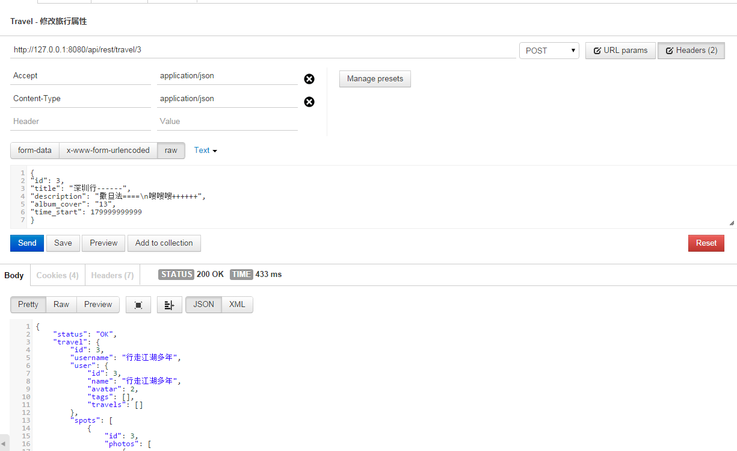

### Get travel

**GET** /api/rest/travel/{id}[?vendor=qq]

|  |
| --- |
| {  "status": "OK",  "travel": {  "id": 4,  "username": "行走江湖多年",  "user": {  "id": 3,  "name": "行走江湖多年",  "avatar": 7,  "tags": [],  "travels": []  },  "spots": [  {  "id": 19,  "photos": [  {  "id": 33,  "point": {  "lat": 30.272869016019456,  "lng": 120.07423458049097,  "alt": 0,  "address": "浙江省杭州市西湖区蒋村街道西溪国家湿地公园"  },  "vendor": "gaode",  "width": 2688,  "height": 1520,  "is360": false,  "tags": [],  "create_time": 1403788921000,  "user_id": 3,  "travel_id": 4,  "travel_name": "端午杭州行",  "like_count": 0,  "fav_count": 0,  "comment_count": 0,  "file_size": 2224528,  "file_name": "IMG_20140601_120024.jpg",  "file_type": "jpg",  "date_time": 1401595224000,  "oss_key": "33.jpg"  },  ...  ],  "title": "端午杭州行",  "user_id": 3,  "album_cover": {  "id": 33,  "point": {  "lat": 30.272869016019456,  "lng": 120.07423458049097,  "alt": 0,  "address": "浙江省杭州市西湖区蒋村街道西溪国家湿地公园"  },  "vendor": "gaode",  "width": 2688,  "height": 1520,  "is360": false,  "tags": [],  "create_time": 1403788921000,  "user_id": 3,  "travel_id": 4,  "travel_name": "端午杭州行",  "like_count": 0,  "fav_count": 0,  "comment_count": 0,  "file_size": 2224528,  "file_name": "IMG_20140601_120024.jpg",  "file_type": "jpg",  "date_time": 1401595224000,  "oss_key": "33.jpg"  },  "photo_size": 9,  "message_id": 42  }  } |
|  |

### 删除旅行

**DELETE** /api/rest/travel/{id}

### Get travel spot

**GET** /api/rest/travel/{id}/spot/{spotId}

### Edit travel spot

**POST** /api/rest/travel/{id}/spot/{spotId}



如果不想更改其中的某个属性，则不要填写该属性；  
如果要置空某个属性，则要传入属性名并且值为空；  
如果photo不存在此spot中，则会加入此spot并会从原来的spot中删除；

如果photo的point有值，则会更新photo的位置信息；

如果photo的date_time有值，则会更新photo的拍摄日期；

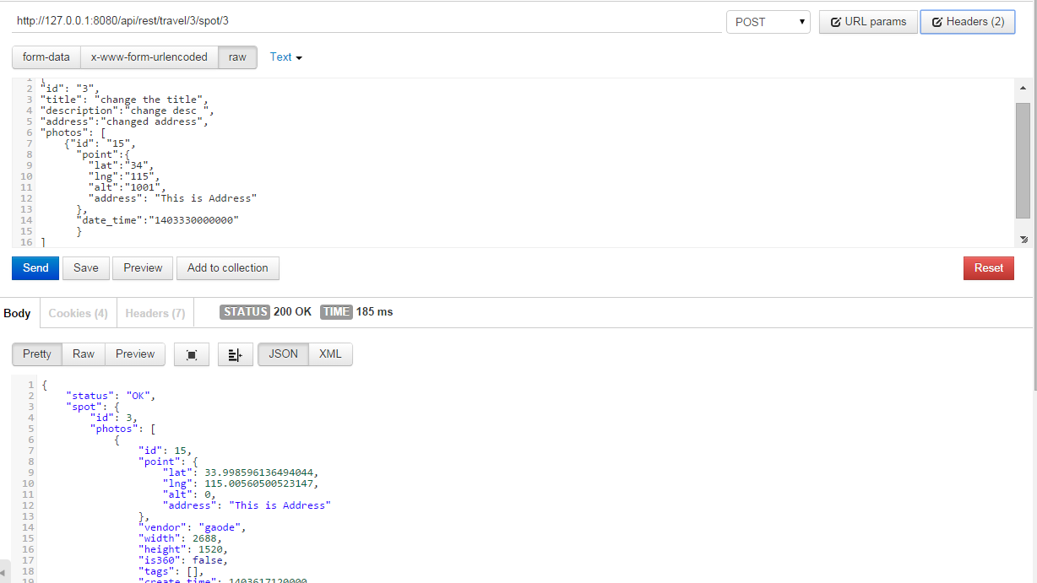

### Add photos to travel

**POST** /api/rest/travel/{id}/photo



|  |
| --- |
| photos: 1,2,3,4,5 |

### Change spot’s photos position

**POST** /api/rest/travel/{id}/spot/position

### Create travel’s spot

**POST** /api/rest/travel/{id}/spot



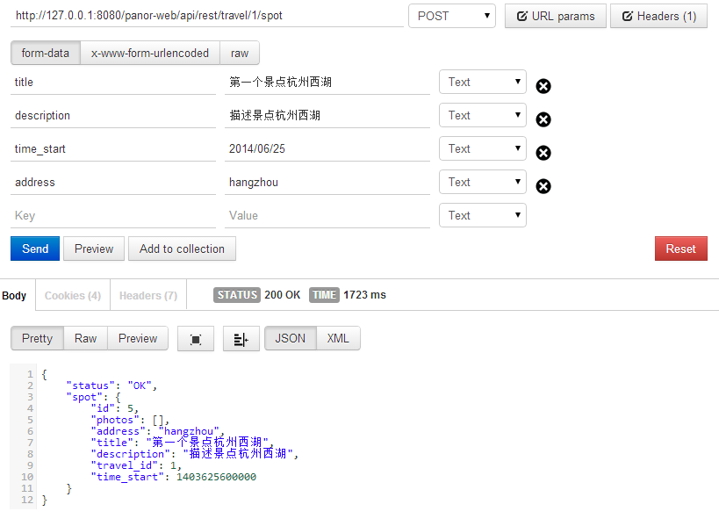

### Add photos to spot

**POST** /api/rest/travel/{id}/spot/{spotId}/photo



## User settings

### Get user settings

**GET** /api/rest/settings/{userId}

### Change Map vendor

**POST** /api/rest/settings/{userId}/map

### Change password

**POST** /api/rest/settings/{userId}/password

### Change account

**POST** /api/rest/settings/{userId}/account

## Recycle

### Get user’s recycle bin data

**GET** /api/rest/recycle

### Empty user’s Recycle bin-清空回收站

**DELETE** /api/rest/recycle

清空用户回收站

### Remove recycle-永久删除

**GET** /api/rest/recycle/{recycleId}

### Cancel recycle-撤销删除

**DELETE** /api/rest/recycle/{recycleId}/cancel

撤销删除操作

# Rest service error_message results

|  |
| --- |
| {  "status": "ACCESS_DENIED",  "info": "Access Denied!"  } |

Status:

|  |  |  |
| --- | --- | --- |
| **status** | **info** | **说明** |
| ID_FORMAT_ERROR |  | 请求参数转换错误 |
| NO_AUTHORIZE |  | 未授权 |
| NO_ENTITY |  | 找不到对象 |
| ACCESS_DENIED |  | 访问被拒绝 |
| EXCEPTION |  | 内部异常 |

# jsp url path

## map photo

/map_photo/?id={photoId}

从/photo/{photoId}转过来，再返回/photo/{photoId}

## User page

/user/{userId}[?show=best&with_photo_id={photoId}]

## Map

### 查看全部图片

/map#lt=37.173581&ln=116.331544&z=12&k=1&a=1&tab=4&pl=all

### 查看user自己的图片

/map/?user={userId}#lt=37.173581&ln=116.331544&z=12&k=1&a=1&tab=4&pl=all

### 查看user收藏的图片

/map/?user={userId}&favorite={true}#lt=37.173581&ln=116.331544&z=12&k=1&a=1&tab=4&pl=all

## Offensive photo

/offensive/photo?id={photoId}

## Photo explorer

/photo_explorer#view=photo&position=485&with_photo_id=101846402&order=date_desc&user=5350181

## Tags

/tags

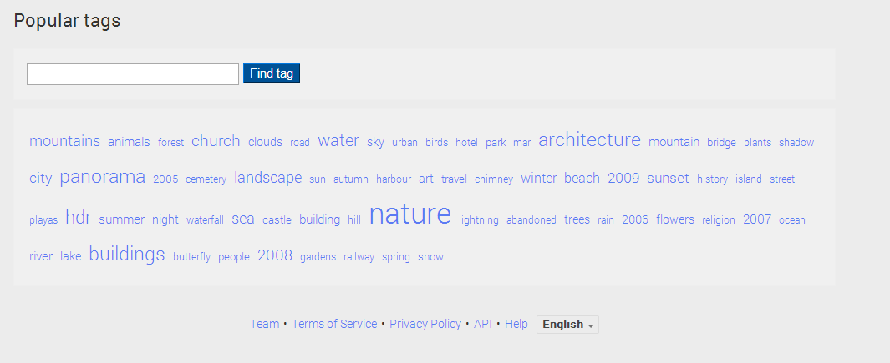

跳转到

/map/?tag=mountains#lt=33.179649&ln=104.460938&z=13&k=1&a=1&tab=3&pl=all

# Sql procedure

## Update photo index

更新photo索引表

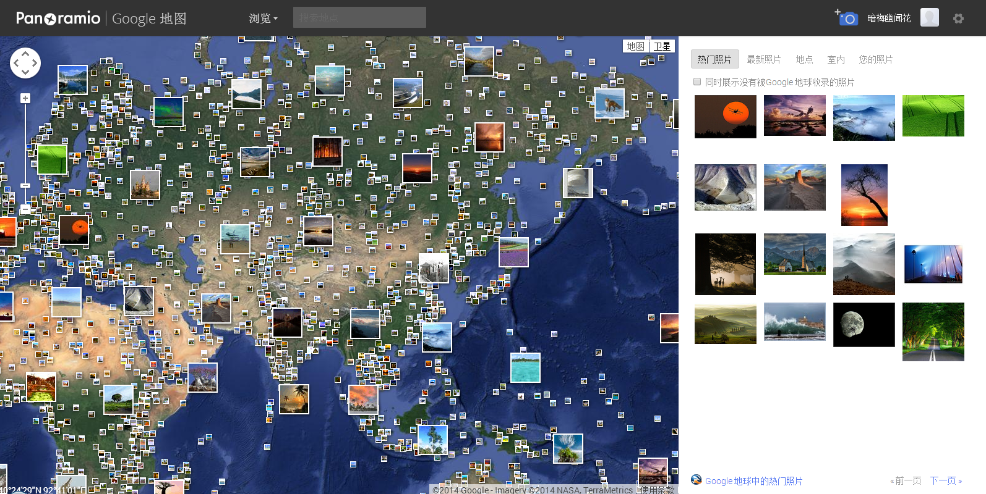

## Get photo by map bound and zoom[ by user]

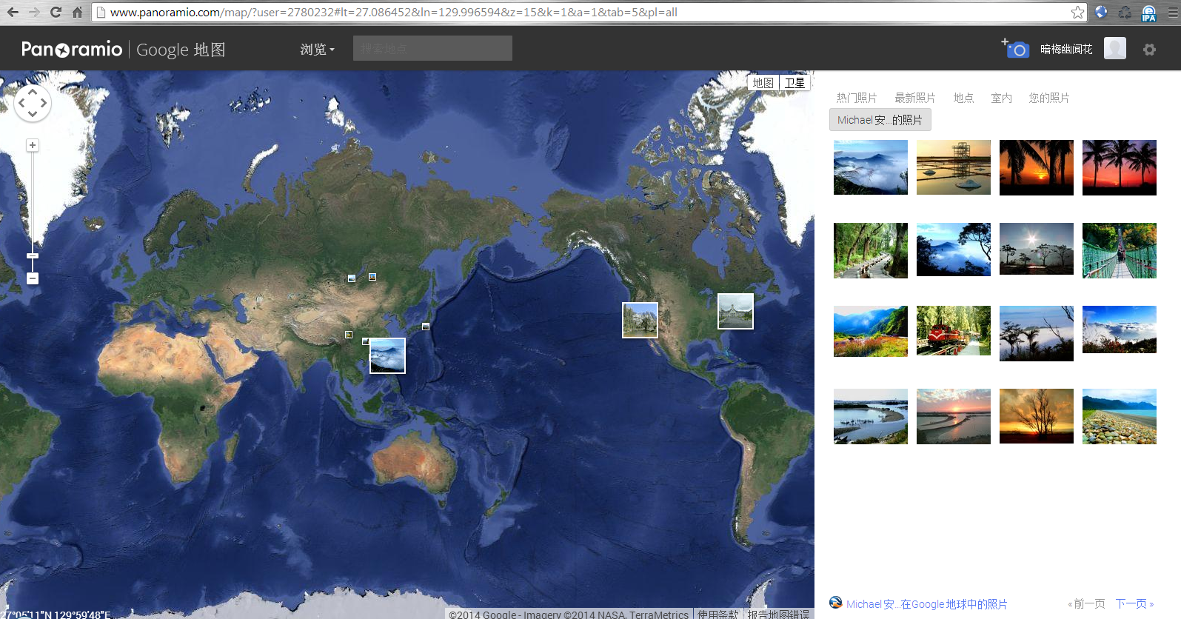

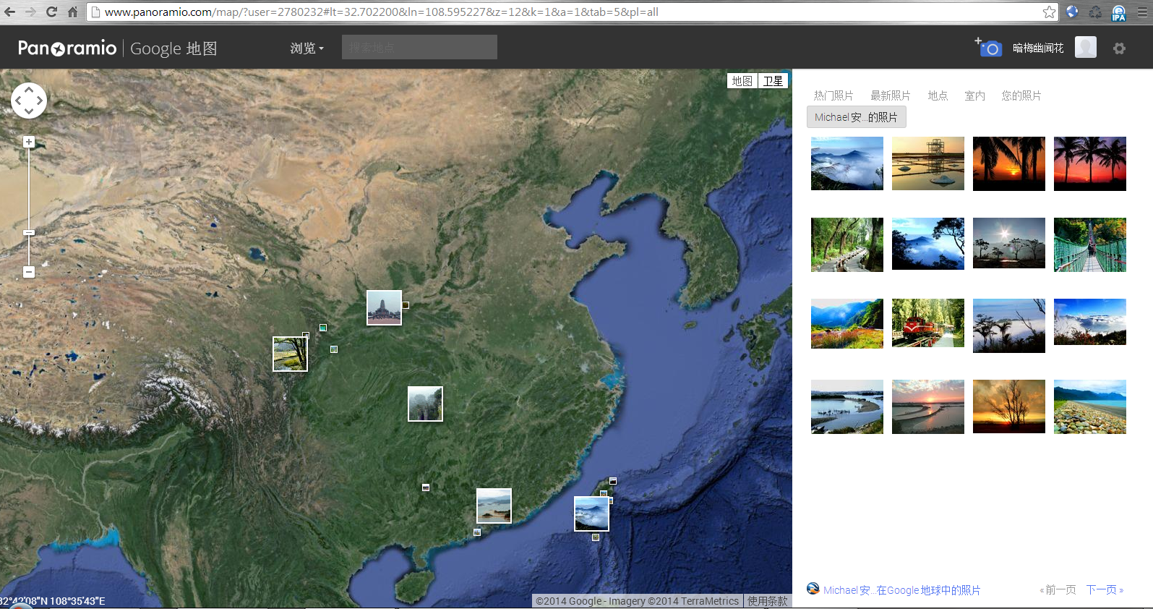

## Get user’s photo by date or location

### Get user’s photo panormaio

|  |  |  |  |
| --- | --- | --- | --- |
| Input parameter | Type |  | Desc |
| i_swLat | double |  | 西南坐标纬度 |
| i_swLng | double |  | 西南坐标经度 |
| i_neLat | double |  | 东北坐标纬度 |
| i_neLng | double |  | 东北坐标经度 |
| i_level | int(2) |  | 地图缩放级别 |
| i_vendor | char(50) |  | 地图供应商 |
| i_width | int4 |  | 地图视图宽度 |
| i_height | int4 |  | 地图视图高度 |
| i_userId | BIGINT(20) |  | 用户ID |
|  |  |  |  |

|  |  |  |  |
| --- | --- | --- | --- |
| Output parameter[array] | Type |  | Desc |
| photoId | BIGINT(20) |  | 图片ID |
| lat | double |  | 纬度 |
| lng | double |  | 经度 |
| alt | double |  | 海拔高度 |
| rating | double |  | Rating |
| title | char |  | title |
| address | char |  | 地址 |

## Get photo’s near photos by location

# Login

Curl parameters

curl -d "j_username=frank" -d "j_password=1234" <http://localhost:8080/panor-web/login>

curl post

# Framework

## growl-like notifications for angularJS projects

<https://github.com/marcorinck/angular-growl>

## Zero watches binding for AngularJs

<https://github.com/Pasvaz/bindonce>

## i18n in your Angular apps, made easy.

http://angular-translate.github.io

https://github.com/angular-translate/angular-translate

## Highcharts JS, the JavaScript charting framework

http://www.highcharts.com

https://github.com/highslide-software/highcharts.com/

https://github.com/pablojim/highcharts-ng

## The ZeroClipboard library provides an easy way to copy text to the clipboard using an invisible Adobe Flash movie and a JavaScript interface.

http://zeroclipboard.org/

https://github.com/zeroclipboard/zeroclipboard

## angularjs validate

<http://angular-ui.github.io/ui-utils/#/validate>

## Copy to clipboard using AngularJS

<https://github.com/asafdav/ng-clip>

## A spinning activity indicator

<http://fgnass.github.io/spin.js/>

<https://github.com/fgnass/spin.js/>

## JavaScript source code visualization, static analysis, and complexity tool

https://github.com/es-analysis/plato

http://www.arcgis.com/

## qTip is an advanced tooltip plugin for the ever popular jQuery JavaScript framework.

<https://github.com/Craga89/qTip1>

## Introducing a jQuery tooltip plugin for control-obsessed designers.

<https://github.com/briancray/tooltipsy>

## A powerful, flexible jQuery plugin enabling you to easily create semantic, modern tooltips enhanced with the power of CSS.

<http://iamceege.github.io/tooltipster/>

<https://github.com/iamceege/tooltipster/>

## Tether - A client-side library to make absolutely positioned elements attach to elements in the page efficiently.

<https://github.com/HubSpot/tether>

## angular-tooltip Simple and extensible tooltips for angularjs

<https://github.com/remind101/angular-tooltip>

## A project to create a robust set of Angular.js bindings for Kendo UI widgets

<https://github.com/kendo-labs/angular-kendo/>

## Kendo UI Labs

<http://kendoui-labs.telerik.com/>

## The jQuery plugin for magical scroll interactions

<https://github.com/janpaepke/ScrollMagic>

## Tiny but perfect jQuery scrollbar plugin

<https://github.com/noraesae/perfect-scrollbar>

## small jQuery plugin that transforms any div into a scrollable area with a nice scrollbar.

<https://github.com/rochal/jQuery-slimScroll/>

## A jQuery plugin to stop the jank of page loads.

<https://github.com/weblinc/jquery.smoothState.js>